***Lab 3 –Abstract Class and Interfaces***

***Answer the following questions.***

Exercise:

1. Consider the UML diagram:

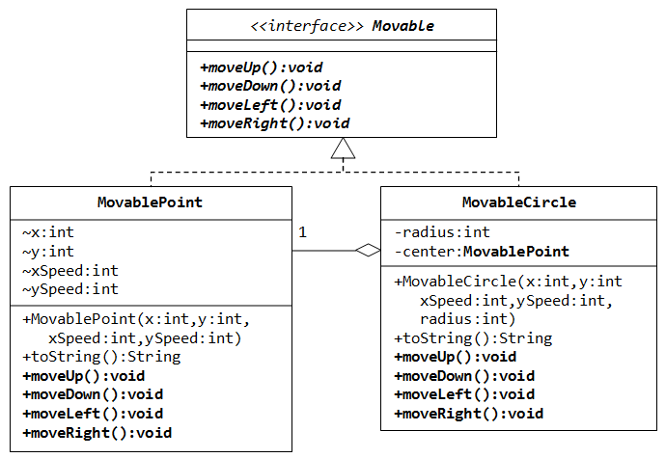

Write a program that demonstrate Movable interface and MovablePoint and MovableCircle classes. State any assumption for your program.